Day 5 – JIRA Issue Management
Date: 31-Dec-2025
Learning Objective
To understand how to create, edit, link, clone, and assign issues in JIRA, and to gain hands-on practice in linking issues for better traceability and dependency management.
Detailed Learning Description
1. Issue Creation
On Day 5, I learned how to create issues in JIRA to track different types of work within a project. Issue creation is a core activity that allows teams to record requirements, tasks, and defects.
• Created issues by selecting appropriate issue types
• Entered issue details such as summary, description, priority, assignee, and labels
• Understood the importance of accurate issue information for effective tracking
My practice:
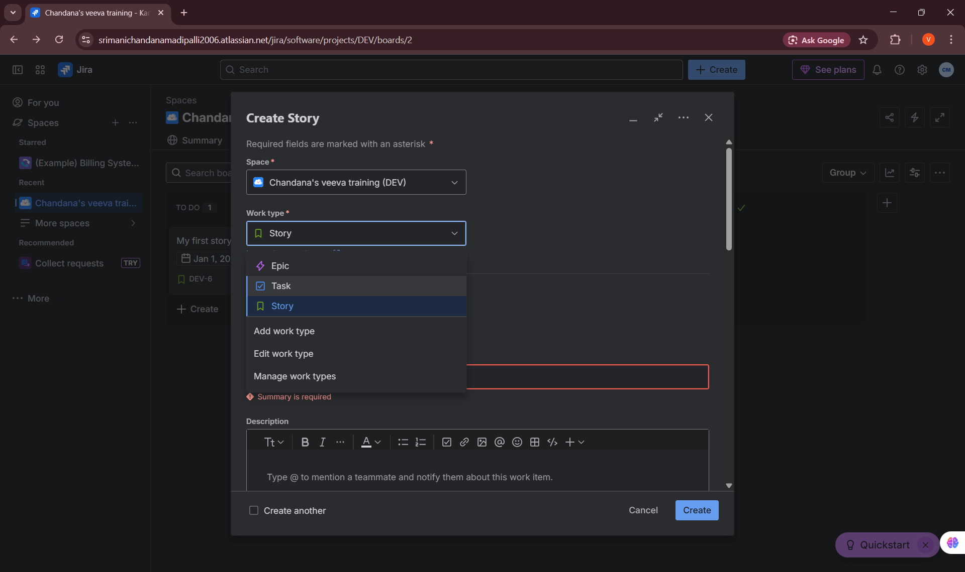

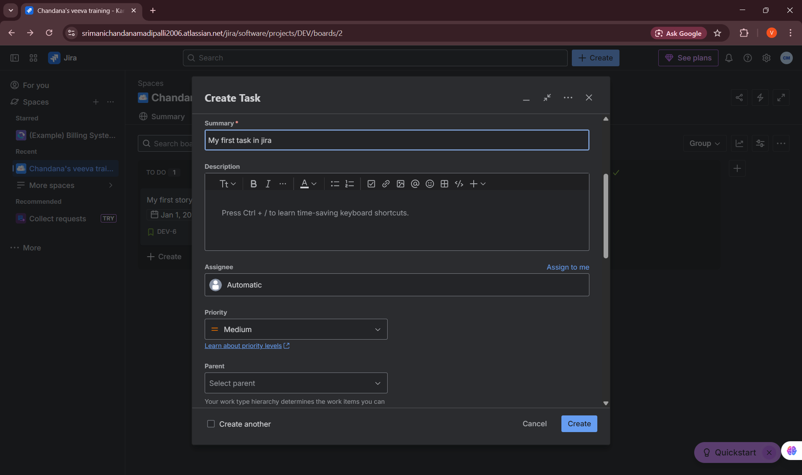

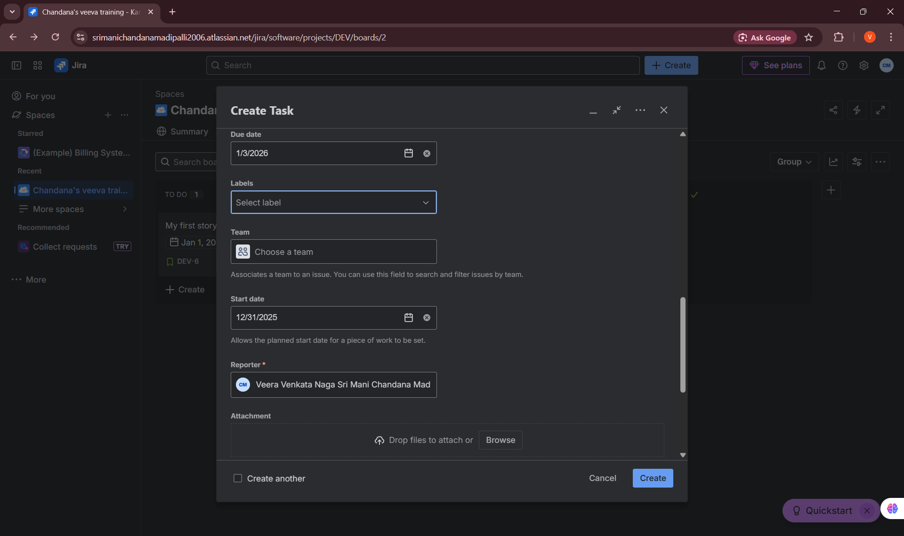

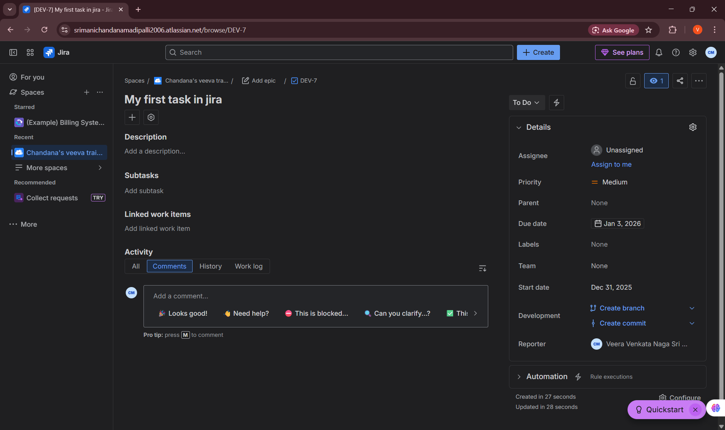

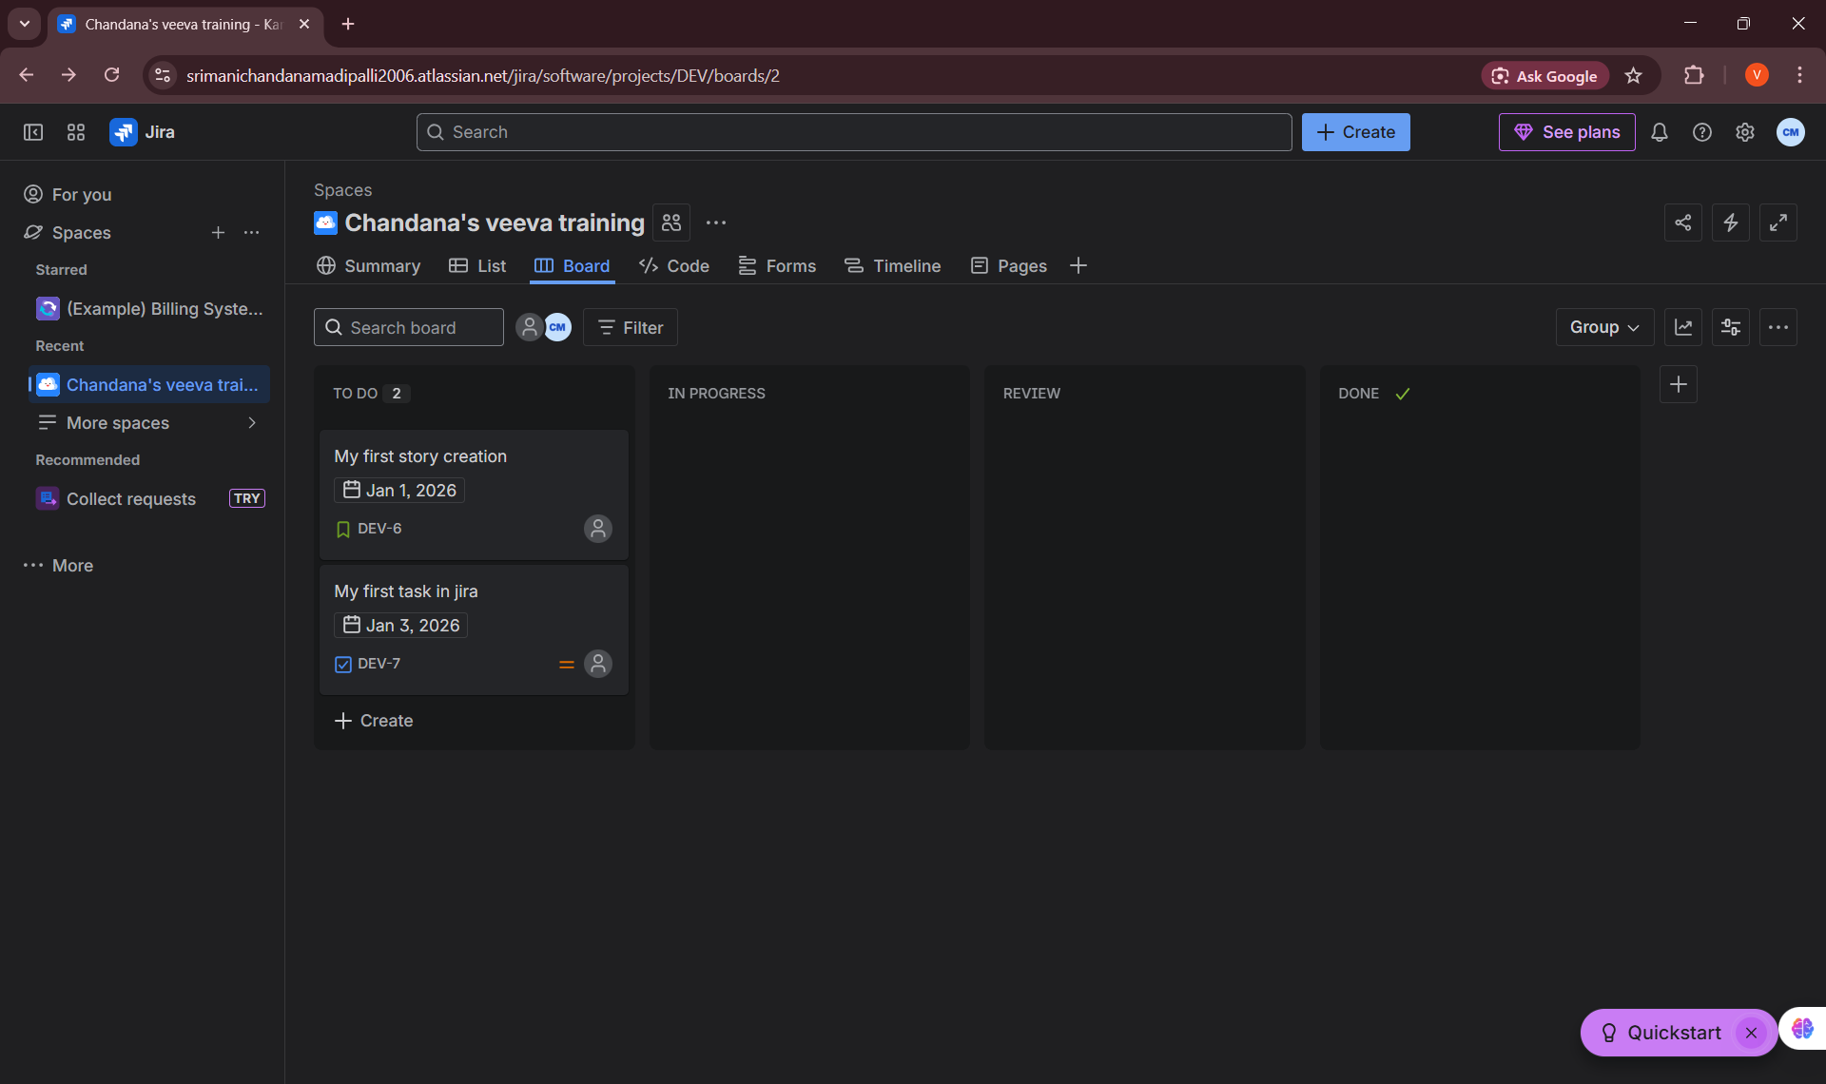

2. Editing Issues
I learned how to modify existing issues to keep information up to date as work progresses.
• Edited issue fields such as description, priority, status, and assignee
• Understood how updates reflect in boards and reports
• Learned the importance of maintaining accurate issue data throughout the lifecycle
My practice:
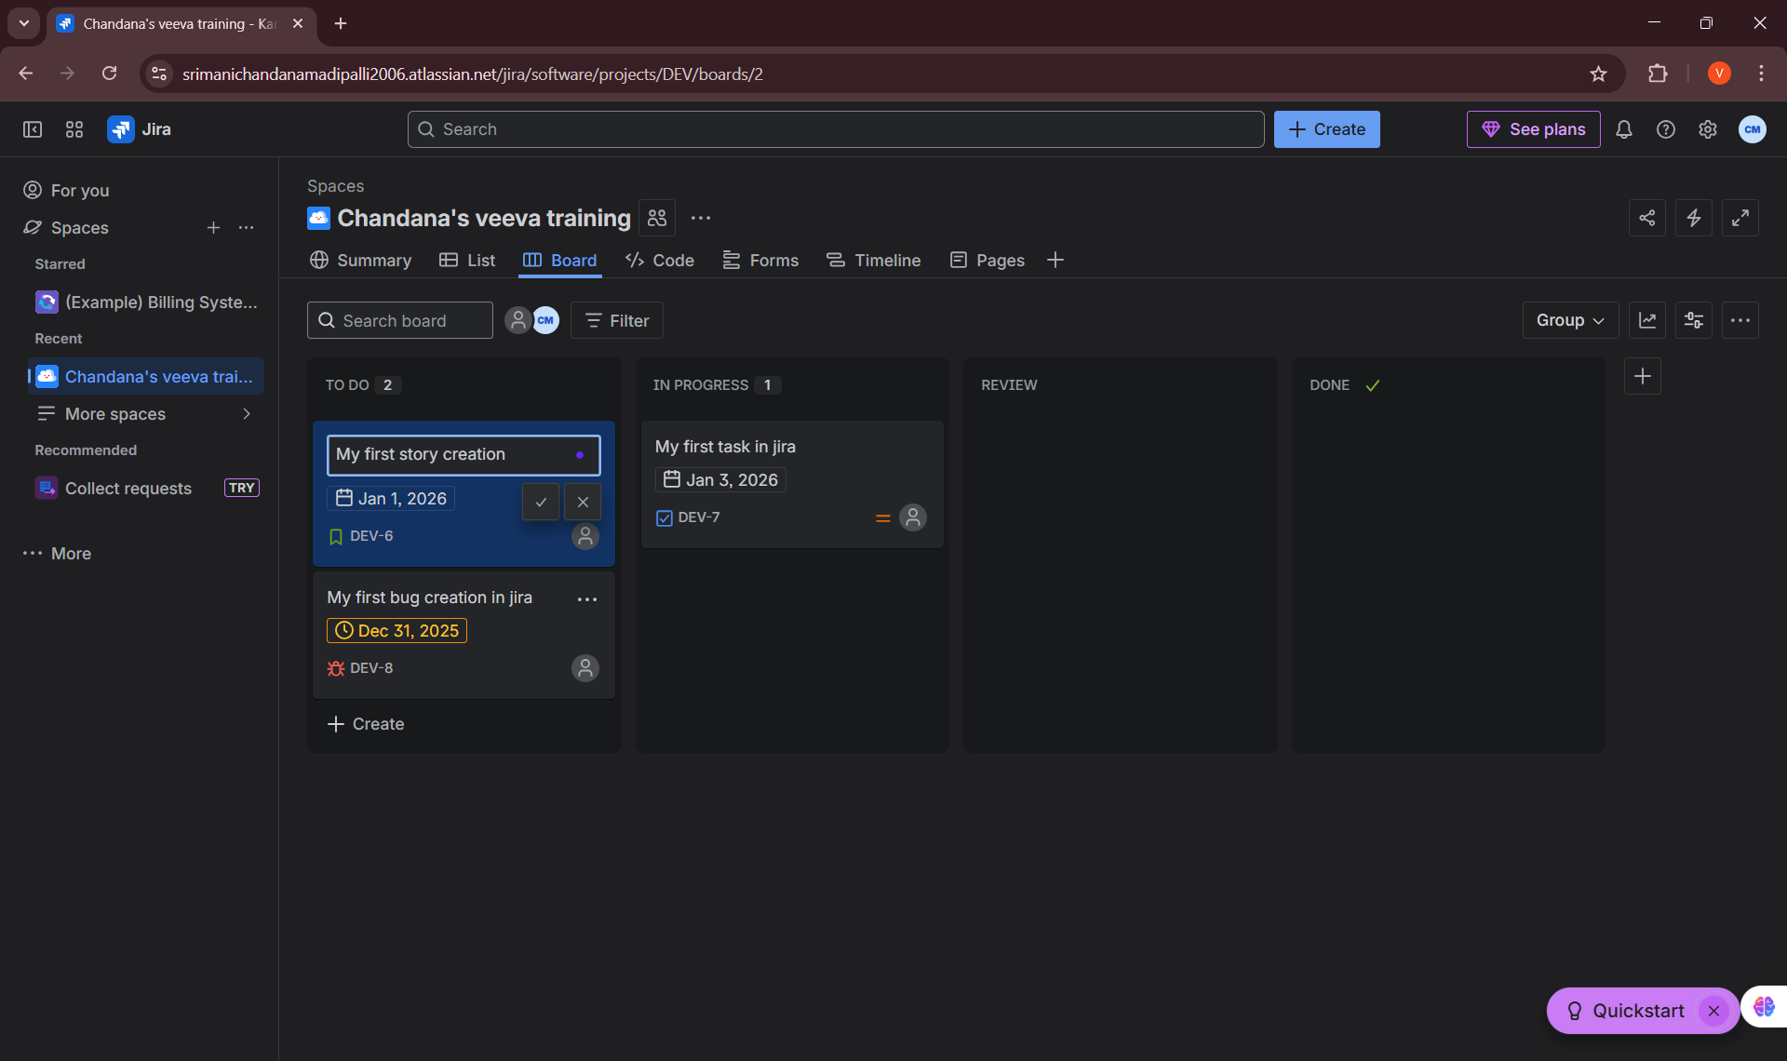

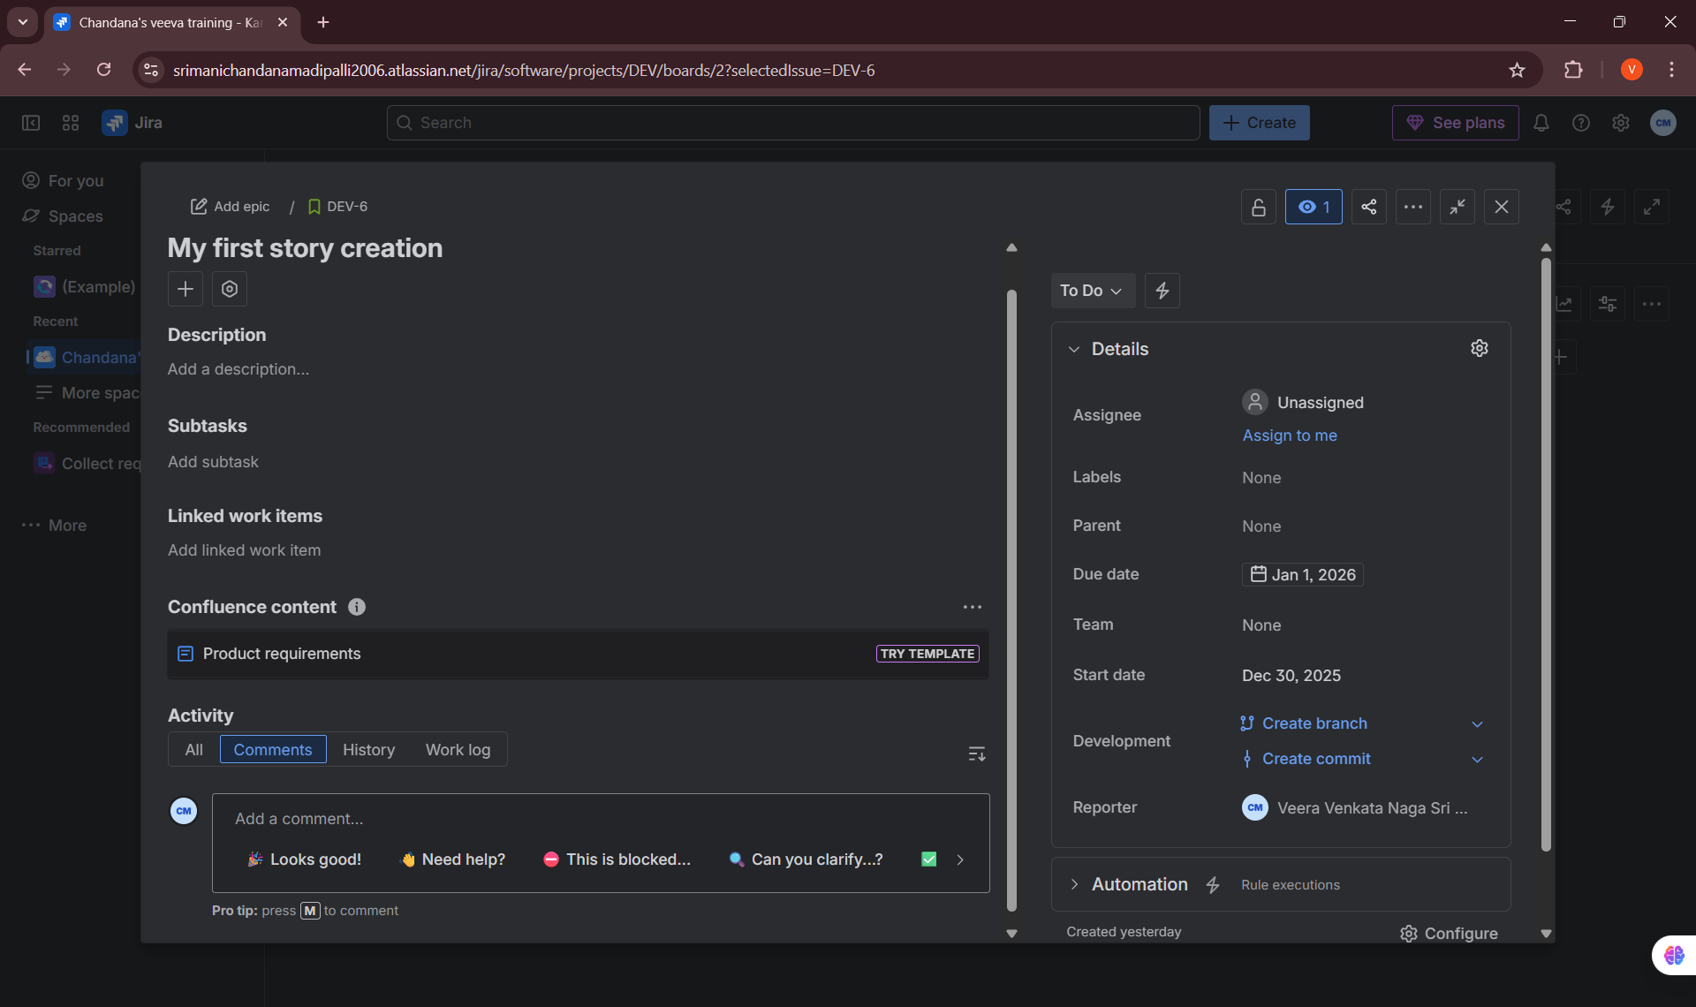
3. Assigning Issues
I practiced assigning issues to team members to ensure clear ownership and accountability.
• Assigned issues to users based on roles and responsibilities
• Understood how assignees receive notifications
• Learned how assignment helps in workload distribution and accountability
My practice:
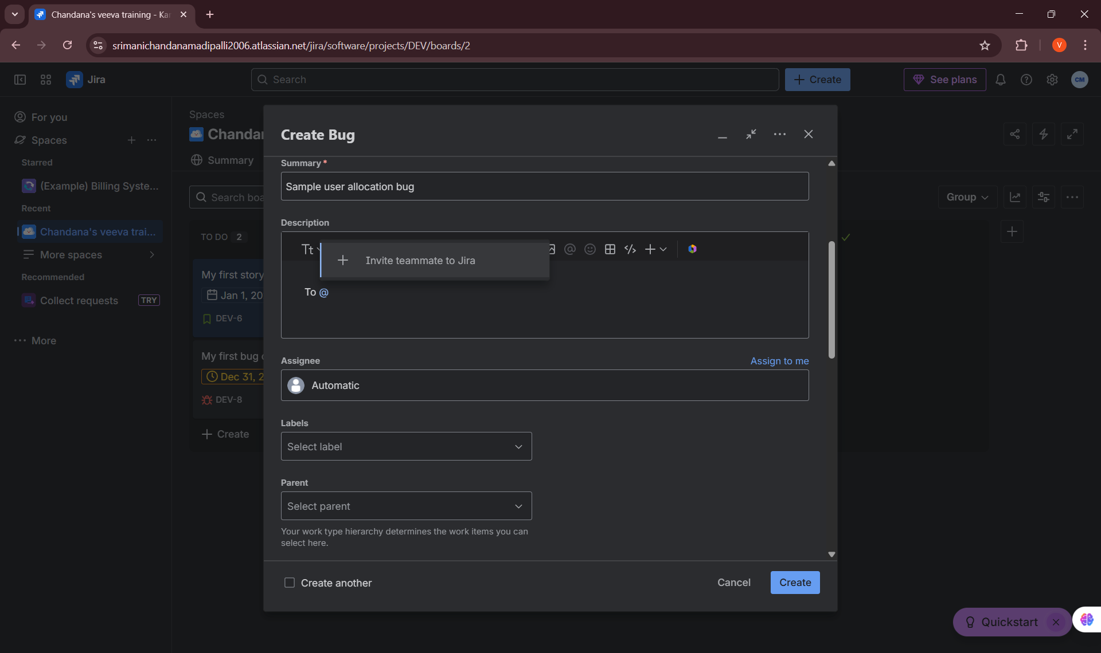

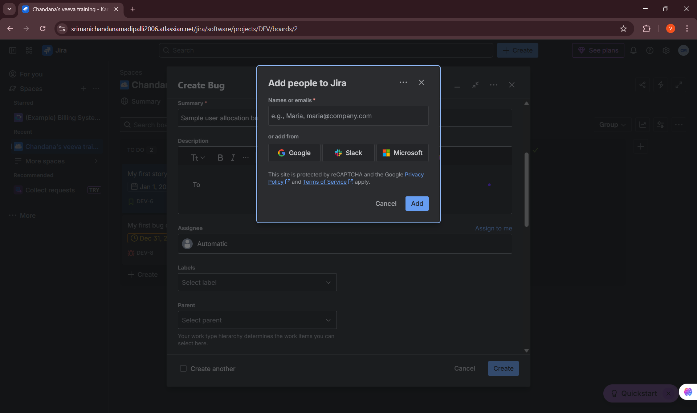

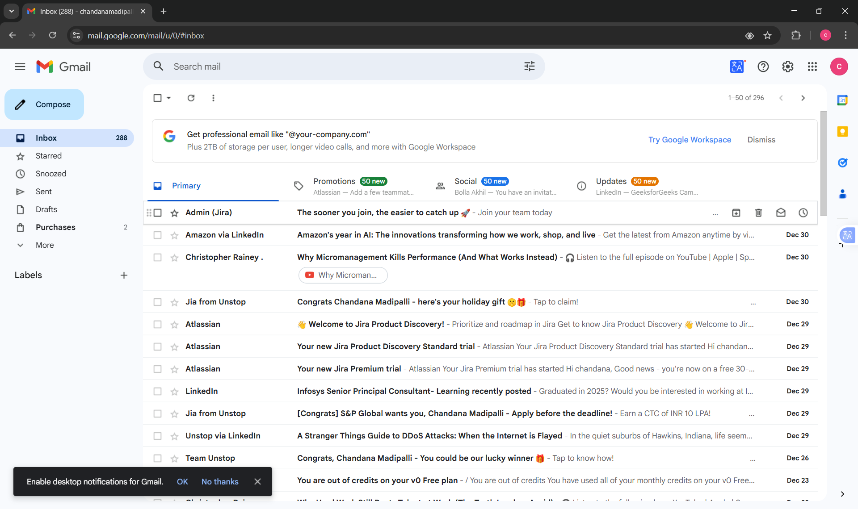

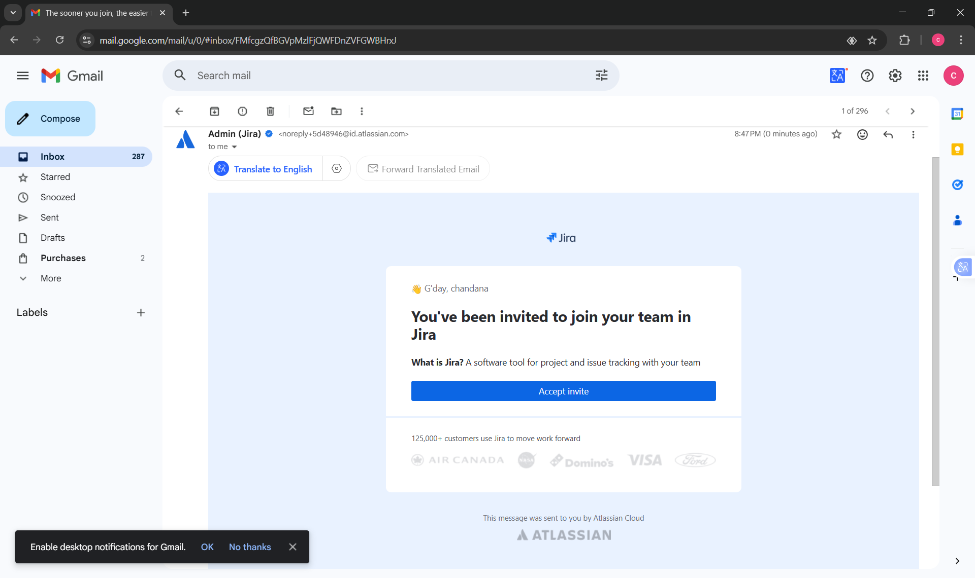

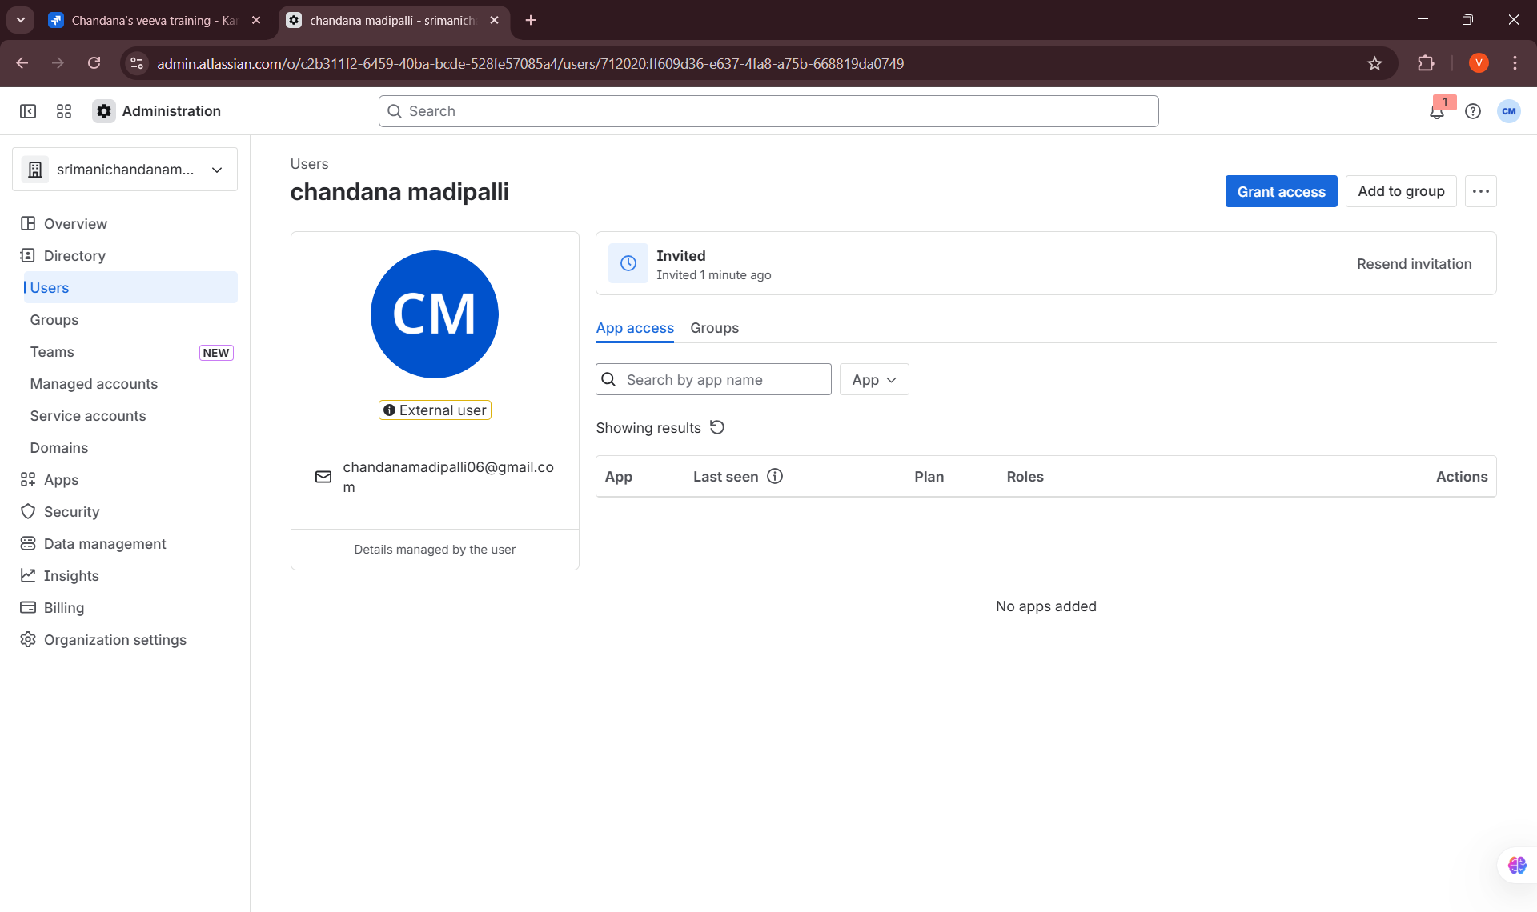

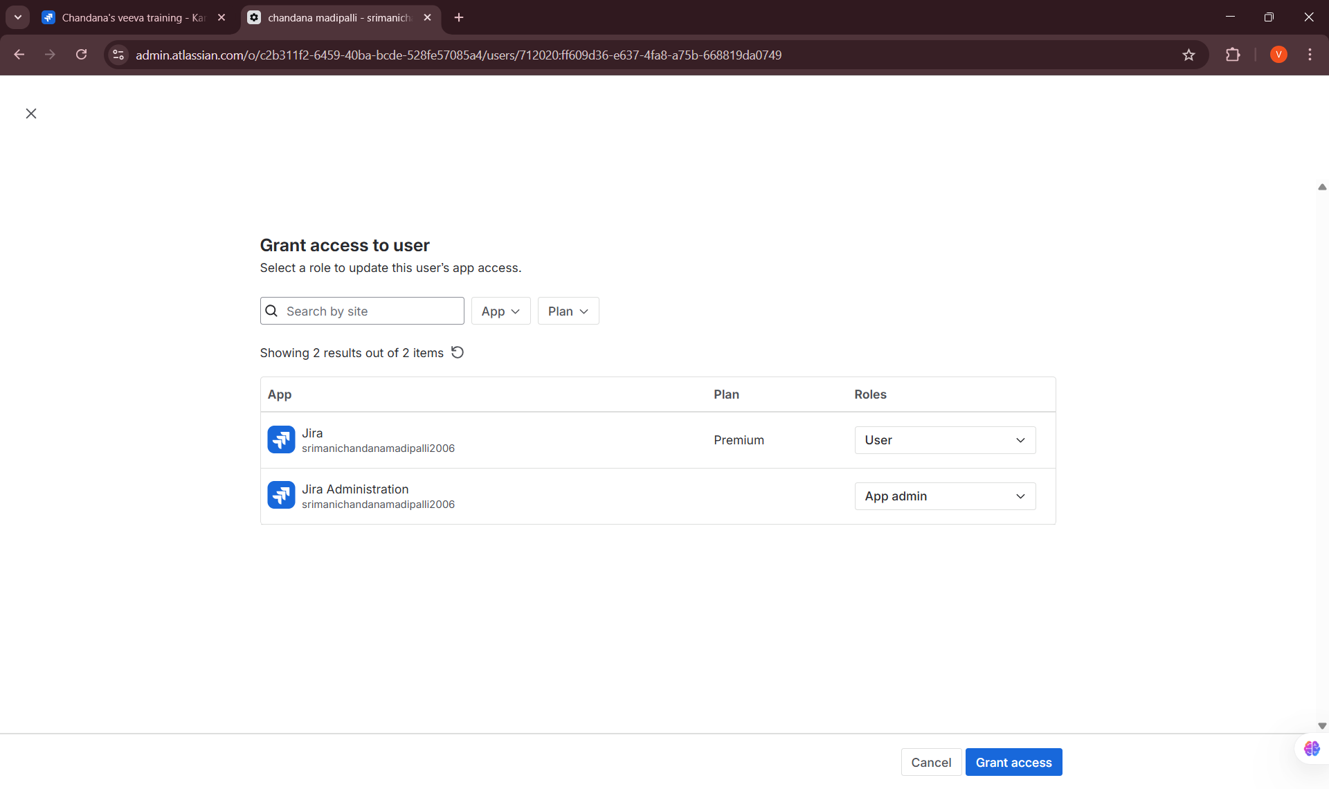

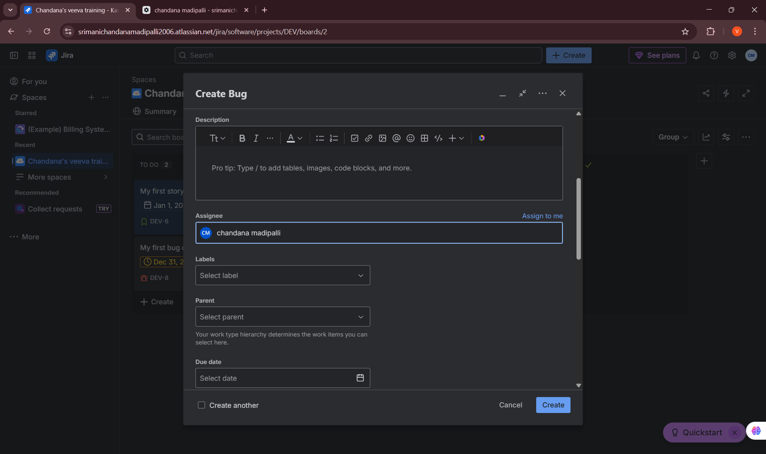

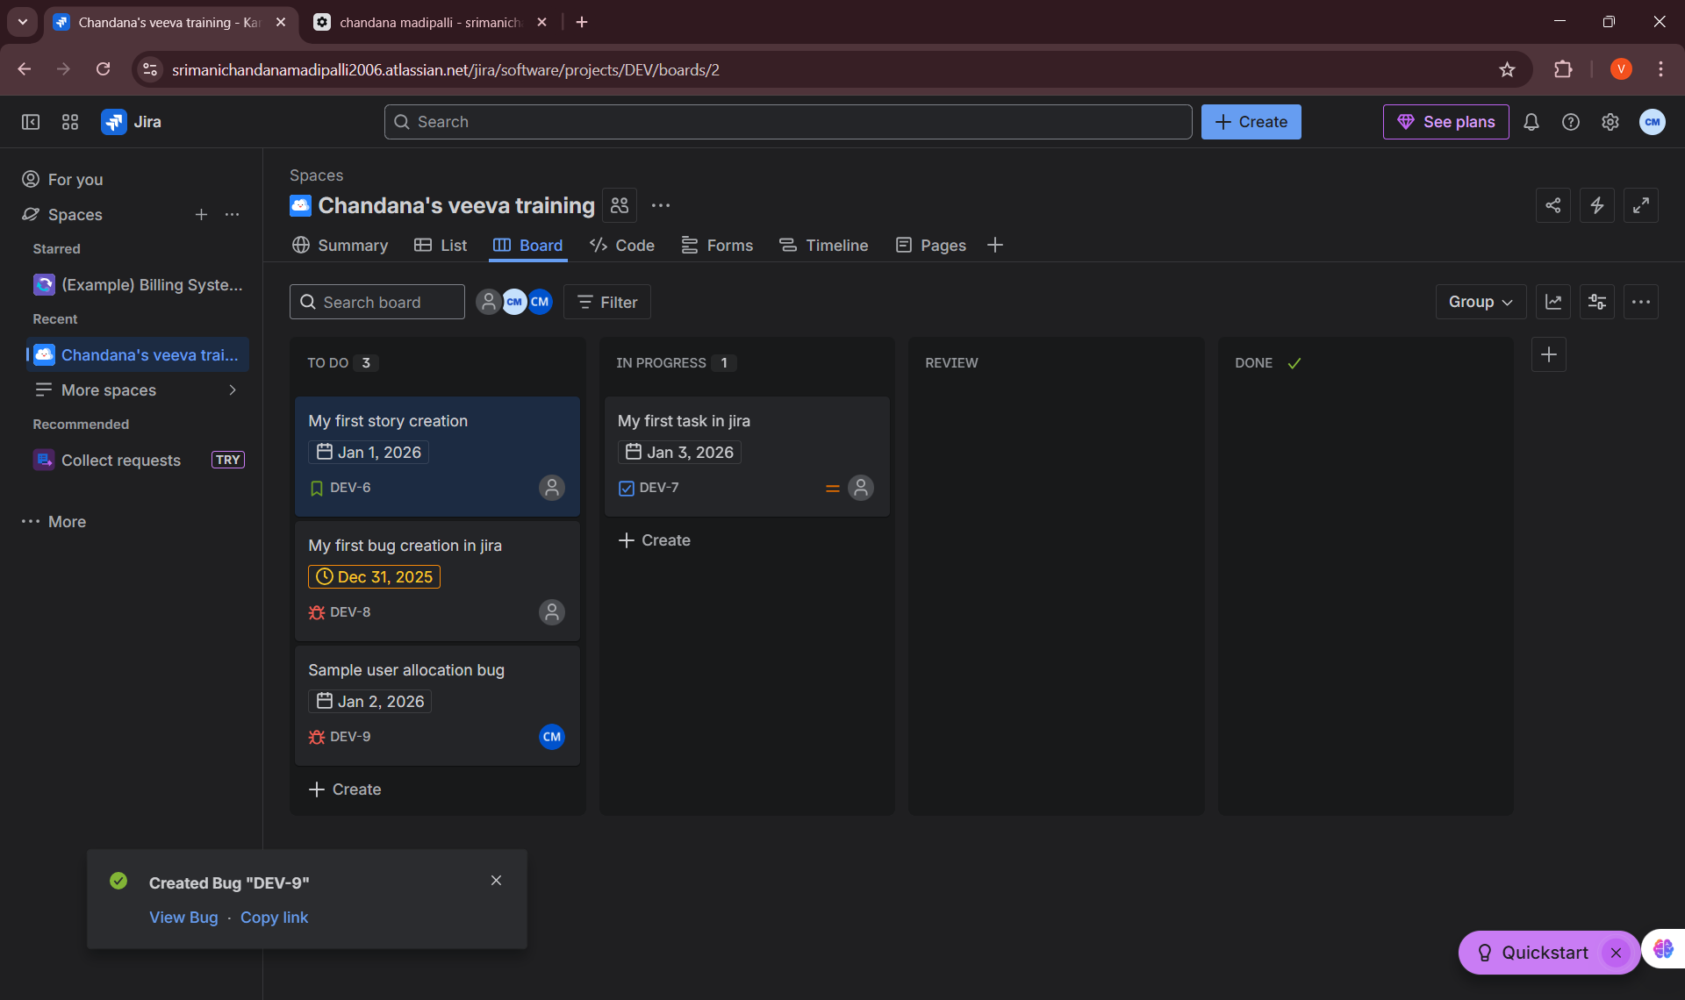

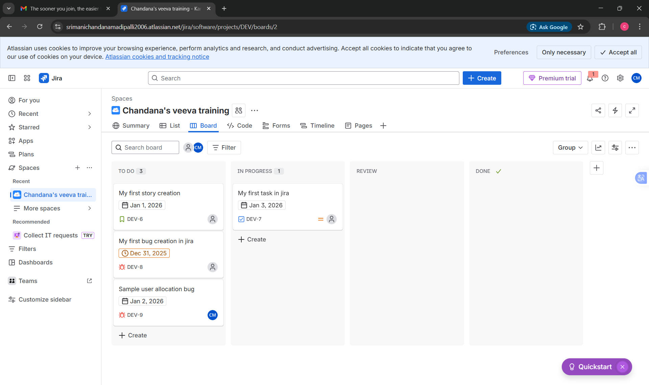
4. Cloning Issues
I learned how to clone issues to reuse existing issue details when similar work needs to be tracked.
• Cloned issues to create duplicates with similar configurations
• Modified cloned issues as per new requirements
• Understood how cloning saves time and maintains consistency
5. Linking Issues
I learned the importance of linking issues to represent relationships and dependencies between work items.
• Linked issues using relationships such as “blocks,” “is blocked by,” “relates to,” and “duplicates”
• Understood how issue links help track dependencies across tasks and stories
• Learned how linking improves traceability and project visibility
6. Practice: Linking Issues
Hands-on practice was performed to strengthen understanding of issue relationships.
• Practiced linking stories to epics and tasks
• Linked dependent issues to simulate real project scenarios
• Verified linked issues through issue view and navigation
Key Learnings & Outcomes
• Gained confidence in creating and managing issues in JIRA
• Learned how to edit, assign, clone, and link issues effectively
• Developed practical understanding of issue dependencies and relationships
• Improved ability to manage issue lifecycle in a collaborative environment
• Built a strong foundation for real-world Agile issue management

